Lab 10.2.2.9 Observing DNS Resolution

1. Objectives

Part 1: Observe the DNS Conversion of a URL to an IP Address

Part 2: Observe DNS Lookup Using the Nslookup Command on a Web Site

Part 3: Observe DNS Lookup Using the Nslookup Command on Mail Servers

1. Background / Scenario

The **Domain Name System (DNS)** is invoked when you type a Uniform Resource Locator (URL), such as <http://www.cisco.com>, into a web browser. The first part of the URL describes which protocol is used. Common protocols are Hypertext Transfer Protocol (HTTP), Hypertext Transfer Protocol over Secure Socket Layer (HTTPS), and File Transfer Protocol (FTP).

DNS uses the second part of the URL, which in this example is www.cisco.com. DNS translates the domain name (www.cisco.com) to an IP address to allow the source host to reach the destination host. In this lab, you will observe DNS in action and use the **nslookup** (name server lookup) command to obtain additional DNS information. Work with a partner to complete this lab.

1. Observe the DNS Conversion of a URL to an IP Address
   * 1. Click the **Windows + r** button, type **cmd** into the search field,and press Enter. The command prompt window appears.
     2. At the command prompt, ping the URL for the Internet Corporation for Assigned Names and Numbers (ICANN) at **www.icann.net**. ICANN coordinates the DNS, IP addresses, top-level domain name system management, and root server system management functions. The computer must translate www.icann.net into an IP address to know where to send the Internet Control Message Protocol (ICMP) packets.
     3. The first line of the output displays www.icann.net converted to an IP address by DNS. You should be able to see the effect of DNS, even if your institution has a firewall that prevents pinging, or if the destination server has prevented you from pinging its web server.

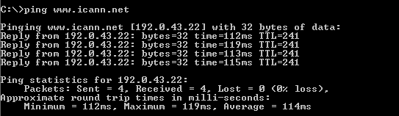

Record the IP Address of www.icann.net___________________________________

* + 1. Type the IP address from **step c** into a web browser, instead of the URL.
    2. Notice that the ICANN home web page is displayed.

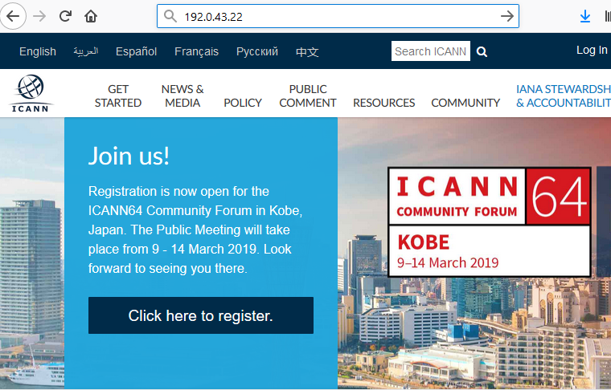

* + 1. Now type **ping** [**www.cisco.com**](http://www.cisco.com).

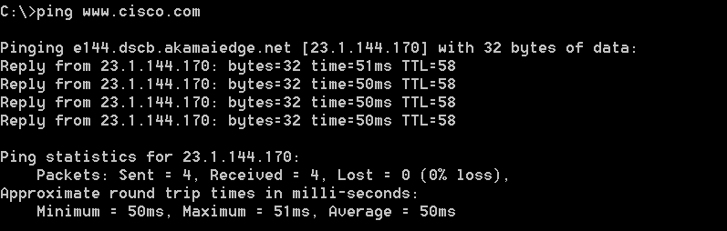

* + 1. When you ping www.cisco.com, do you get the same IP address as the example, or a different IP address, and why?

____________________________________________________________________________

* + 1. Type the IP address that you obtained when you pinged www.cisco.com into a browser. Does the web site display? Why or why not?

____________________________________________________________________________

____________________________________________________________________________

1. Observe DNS Lookup Using the Nslookup Command on a Web Site
   * 1. At the command prompt, type the **nslookup** command.

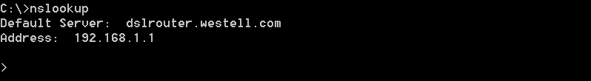

What is the default DNS server used? _________________________________________

Notice how the command prompt changed to a greater than (>) symbol. This is the **nslookup** prompt. From this prompt, you can enter commands related to DNS.

At the prompt, type **?** to see a list of all the available commands that you can use in **nslookup** mode.

At the **nslookup** prompt, type **www.cisco.com**.

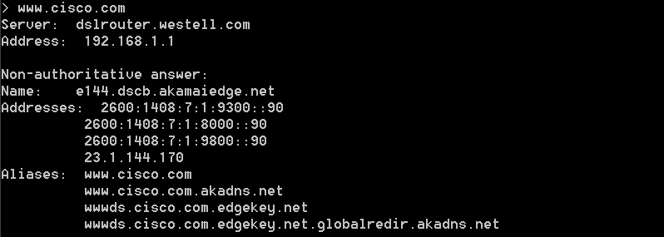

What is the translated IP address? ________________________________________________

Is it the same as the IP address shown with the **ping** command? _________________

Under addresses, in addition to the 23.1.144.170 IP address, there are the following numbers: 2600:1408:7:1:9300::90, 2600:1408:7:1:8000::90, 2600:1408:7:1:9800::90. What are these?

____________________________________________________________________________________

At the prompt, type the IP address of the Cisco web server that you just found. You can use **nslookup** to get the domain name of an IP address if you do not know the URL.

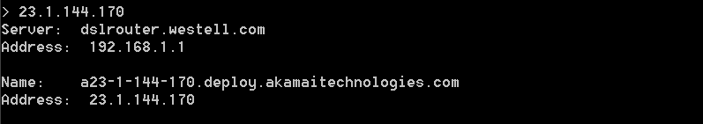

You can use the **nslookup** tool to translate domain names into IP addresses. You can also use it to translate IP addresses into domain names.

Using the **nslookup** tool, record the IP addresses associated with [www.google.com](http://www.google.com).

____________________________________________________________________________________

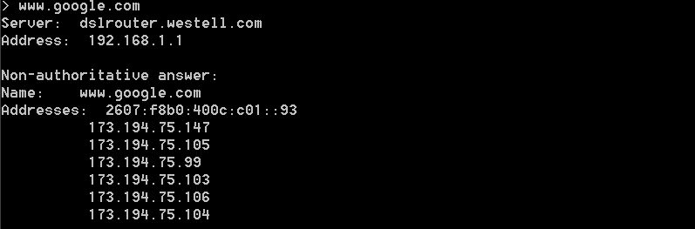

1. Observe DNS Lookup Using the Nslookup Command on Mail Servers
   * 1. At the prompt, type **set type=mx** to use **nslookup** to identify mail servers.

set type mx

* + 1. At the prompt, type **cisco.com**.

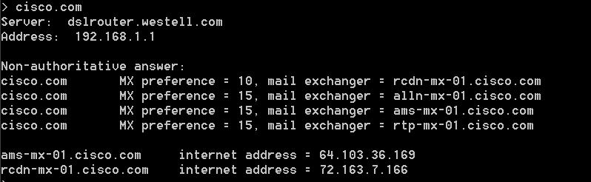

A fundamental principle of network design is redundancy (more than one mail server is configured). In this way, if one of the mail servers is unreachable, then the computer making the query tries the second mail server. Email administrators determine which mail server is contacted first using **MX preference** (see above image). The mail server with the lowest **MX preference** is contacted first. Based upon the output above, which mail server will be contacted first when email is being sent to cisco.com?

____________________________________________________________________________________

* + 1. At the nslookup prompt, type **exit** to return to the regular PC command prompt.
    2. At the PC command prompt, type **ipconfig /all**.
    3. Write the IP addresses of all the DNS servers that your school uses. ____________________________

1. Reflection

What is the fundamental purpose of DNS?

_______________________________________________________________________________________

Lab 10.2.3.3 Exploring FTP

1. Objectives

Part 1: Use FTP from a Command Prompt

Part 2: Download an FTP File Using WS_FTP LE

Part 3: Use FTP in a Browser

1. Background / Scenario

The **File Transfer Protocol (FTP)** is part of the TCP/IP suite. FTP is used to transfer files from one network device to another network device. Windows includes an FTP client application that you can execute from the command prompt. There are also free graphical user interface (GUI) versions of FTP that you can download. The GUI versions are easier to use than typing from a command prompt. FTP is frequently used for the transfer of files that may be too large for attachment with an email.

When using FTP, one computer is normally the server and the other computer is the client. When accessing the server from the client, you need to provide a username and password. Some FTP servers have a user named **anonymous**. You can access these types of sites by simply typing “anonymous” for the user, without a password. Usually, the site administrator has files that can be copied but does not allow files to be posted with the anonymous user.

In this lab, you will learn how to use anonymous FTP from the Windows command-line C:\> prompt. You will also use the GUI-based FTP program, WS_FTP LE. Finally, you will use an anonymous FTP in a browser.

1. Use FTP from a Command Prompt
   * 1. Click the **Windows Start** button, type **cmd** in the search field, and press Enter to open a command window.
     2. At the C:\> prompt type **ftp ftp.cdc.gov**. At the prompt that says **User (ftp.cdc.gov:(none)):** type **anonymous**. For the password, do not type anything. Press Enterto be logged in as an anonymous user.

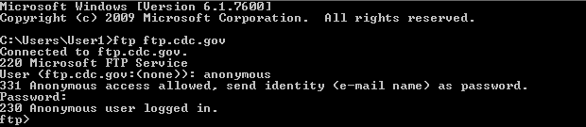

Notice that the C:\> prompt has been replaced with the ftp> prompt. Type **ls** to list the files and directories. At the time that this lab was authored, there was a Readme file.

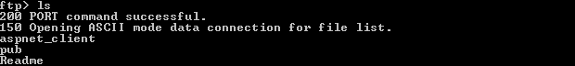

* + 1. At the prompt, type **get Readme**. This downloads the file to your local computer from the anonymous FTP server that the Center for Disease Control has setup. The file will be copied into the directory shown in the C:\> prompt (C:\Users\User1 in this case).

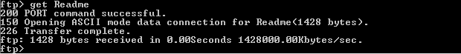

* + 1. Type **quit** to leave FTP and return to the C:\> prompt. Type **more Readme** to see the contents of the document.

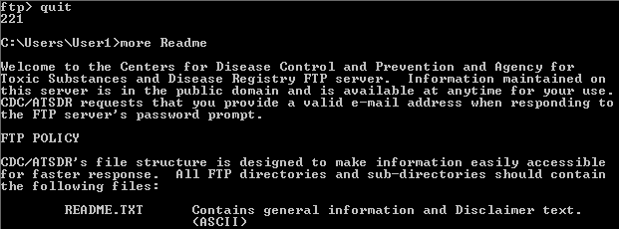

* + 1. What is a drawback of using the FTP from the command line?

____________________________________________________________________________________

1. Download an FTP File Using WS_FTP LE

In Part 2, you will download a file using WS_FTP LE (a free FTP transfer tool).

* + 1. Start **WS_FTP LE**. If the Ipswitch WS_FTP LE window displays, click **Next** to continue and skip to step c. Otherwise, click the **Open a Remote Connection** link.

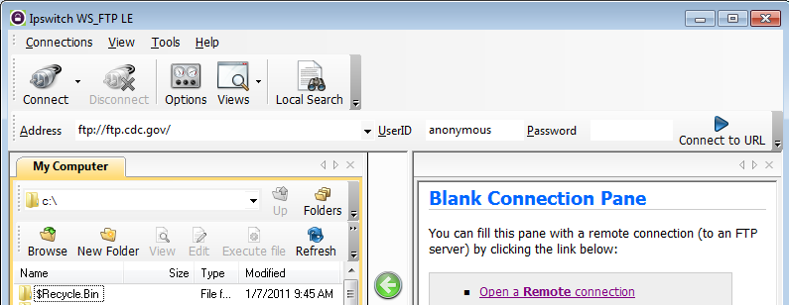

* + 1. Click **Create Site…**

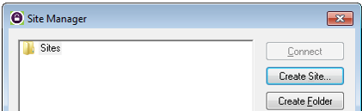

* + 1. In the **Site Name** field, type **Center for Disease Control** and click **Next** to continue.
    2. Click the **Connection Type** drop-down list, select **FTP** (the default connection type), and click **Next**.
    3. In the **Server Address** field, type [**ftp.cdc.gov**](ftp://ftp.cdc.gov),and click **Next**.
    4. In the **User Name** field, type **anonymous**, and leave the password field blank. Click **Next**.

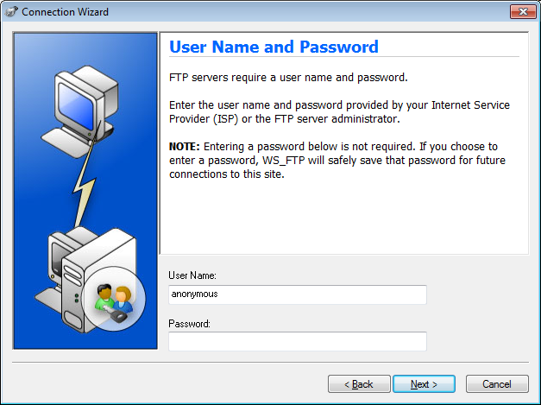

* + 1. Click **Finish**.
    2. When the Login Information Missing dialog box displays, click **OK**. Do not type a password in the **Password** field.
    3. You are now anonymously connected to the Center for Disease Control FTP site.
    4. On the WS_FTP LE toolbar menu under My Computer, click **New Folder** to create a folder on your local **C:\** drive.
    5. In the Make Directory dialog box name the folder as **CDC** and click **OK**.

**Note:** If the folder already exists, you can use the same folder or create another folder with a different name. If using the same CDC folder, you can replace the existing Readme file with the downloaded Readme file.

* + 1. After the directory is created, in the **My Computer** tab page, double-click the directory to open it.
    2. Drag the file **Readme** from the right side of the application (the remote CDC FTP server) into the CDC folder on to the local **C:\** drive.

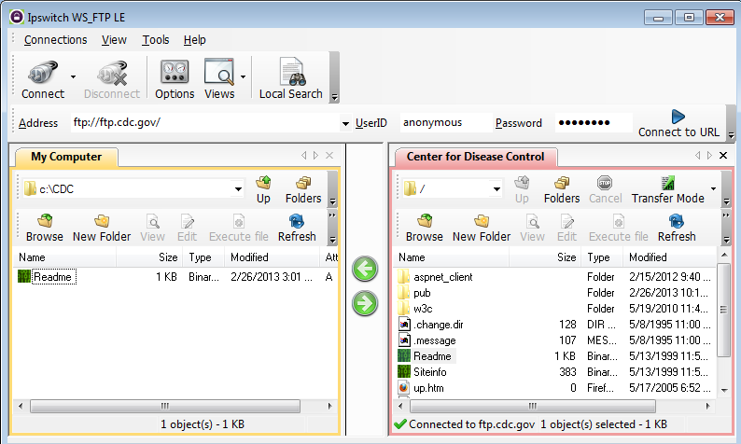

* + 1. Double-click the **Readme** file in the **C:\CDC** folder on your local **C:\** drive. If prompted for an application to open the document, choose any word processing software. You should see a message that looks something like this:

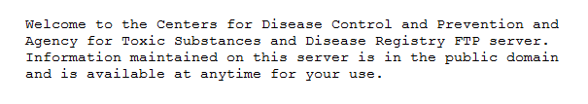

* + 1. Which was easier, using FTP from the **cmd** prompt, or using WS_FTP LE? ________________________
    2. Click **Disconnect** to disconnect from the [ftp.cdc.gov](ftp://ftp.cdc.gov) site when finished.
    3. The remote site will be removed from the saved list of FTP sites. In the Ipswitch WS_FTP LE window, click the **Open a Remote Connection** link. Select the **Center for Disease Control** site, and click **Delete** to remove the FTP site. Click **Yes** to confirm the deletion. Click **Close** to exit the Site Manager.
    4. Remove the **C:\CDC** folder.

1. Use FTP in a Browser

It is possible to use a browser as an anonymous FTP client.

* + 1. In a browser, type [**ftp://ftp.cdc.gov/**](ftp://ftp.cdc.gov/).

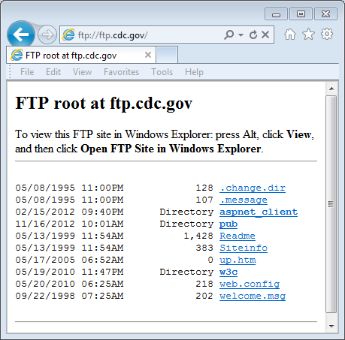

* + 1. Click the **Readme** file.

